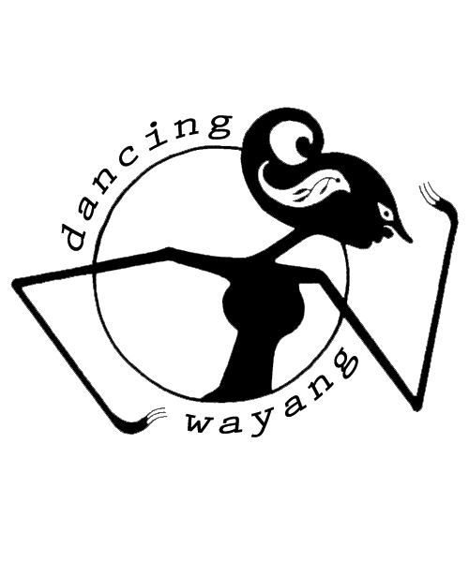

Press Release

Oren Ambarchi / Eli Keszler 180 gram 12” vinyl album (ltd. edition of 500)

ALPS Release Date: 25th August 2014

Dancing Wayang Records is thrilled to announce the imminent release of the label’s ninth longplayer - ALPS by Oren Ambarchi & Eli Keszler; a fresh yet seemingly inevitable collaboration of two musicians kicking against limits and genre definitions, recorded and presented with a similar disregard for anything but quality.

ALPS was recorded in June 2013 at Eastcote Studios in London. Thereafter mixed by frequent Ambarchi associate Joe Talia in Melbourne and mastered by Rashad Becker in Berlin, it comes pressed on 180 gram black virgin vinyl housed in the label’s traditional hand-screenprinted wrap-around sleeves featuring cover art by Eli Keszler. Liner notes come courtesy of US musician C. Spencer Yeh (Burning Star Core).

Two vinyl-side-long pieces that mix improv, noise, rock, and drone, this is never an easy listen but always a compelling one. Both musicians are compulsive collaborators, with individual oeuvres that span all those genres and others yet to be labelled, and this album reflects and distills their hard-working heritage. They have a similar approach to questioning the fundamentals and exploring the sonic properties of their chosen instruments in a way that is informed by musical theory and learning but manifests itself in a defiantly non-academic, visceral and physical sound, both in intent and experience. Listening to ALPS is a discomforting, uneasy and massively rewarding exercise, which denies the listener any steady ground on which to stand.

This is evident from the moment that “Alps I” kicks off with piercing bowed cymbals. Percussive elements emerge from deep in the mix, drums without rhythm nor metre. Background and foreground shift tectonically and queasily. A chopping helicopter pulse hovers omnipresently over the battlefield of attacking drums and splintery bass beneath. It is a liquescent, rolling, never still 20 minutes of multiple musical narratives.

From the outset Side B upholds the intensity. The conflagration of “Alps II” comes off like a tribute to classic Japanese psych; guitar proudly and consistently in the red, tsunamis of drum rolls. It has a defiant crudeness and rawness to its attack, which belies the intelligence needed to create such a rough-edged sound, the deftness needed to keep the truck-driving momentum on the road.

Oren Ambarchi is a composer and multi-instrumentalist whose work focuses mainly on the exploration of the guitar challenging, stretching and bending its traditional use. He has performed and recorded with such luminaries as Jim O’Rourke, Keiji Haino, Sunn O))), John Zorn, Fennesz and many more. His music has been released on labels such as Touch and Editions Mego.
Eli Keszler is a New York based drummer, composer and visual artist. His musical practice explores an “intense physicality and ferocious energy” whilst his multi-facetted art practice can be experienced both visually and sonically. He has played with Tony Conrad, Roscoe Mitchell, Jandek amongst others. His art has been exhibited at the Victoria & Albert Museum, South London Gallery, Centraal Museum (Utrecht) and the Boston Center for the Arts.

For more information contact Anna Tjan / www.dancingwayang.com / info@dancingwayang.com

