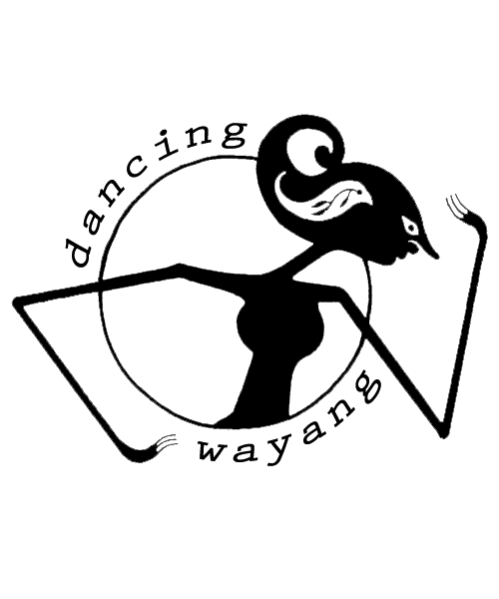
DIRECTING HAND press release

DIRECTING HAND 12” vinyl (ltd. 500)

What Put The Blood release date: March 08

DIRECTING HAND have recorded an exciting and chilling record of folk and fire tunes. Consisting of freely improvised tracks on drums, harp and wordless vocals as well as interpretations of traditional English folk songs, "What Put The Blood" is a true gem. Recorded at Eastcote Studios in London, drummer extraordinaire Alex Neilson and classically trained soprano and multi-instrumentalist Lavinia Blackwall cut loose, turn it up, turn it down and let the air escape their lungs. The result is raw beauty in every way possible and we are incredibly excited to unleash this record onto the world.

The LP features exclusive liner notes by Volcanic Tongue’s David Keenan and comes housed in a hand screenprinted wrap-around sleeve with artwork designed by Lavinia Blackwall.

ALEX NEILSON has been drumming up a storm in the last few years playing with some of the UK’s finest innovators like Richard Youngs, Ashtray Navigations, Taurpis Tula and Scatter as well as collaborating with Ben Reynolds as MOTOR GHOST (Dancing Wayang Records). He accompanied Jandek on his first ever and subsequent UK live shows. More recently Alex has been playing internationally with Bonnie ‘Prince’ Billy and Baby Dee. On “What Put The Blood”, Alex is clearly at the helm exploring his personal interest in uncovering the parallels between improvised, experimental and more traditional folk music.

LAVINIA BLACKWALL is a classically trained singer in Early Music. A member of Glasgow based band Pendulums she also plays piano and organs, guitars, bass and psaltry. Versed in the interpretations of traditional folk and classical songs she is also unafraid to let the ugliest sounds arise from her lungs. This is her debut with Directing Hand.

DANCING WAYANG is a record label operating out of Eastcote Studios, London, and aims to provide artists with free studio time and access to a high quality recording facility and equipment.
The sessions recorded at Eastcote are released in limited run, hand-packaged vinyl editions.
Eastcote is an independently run studio in west London, first established in 1980, and boasts a wide array of vintage and modern equipment and instruments, which artists can use to flesh out their ideas.

For more information contact
Anna Tjan | Dancing Wayang Records | www.dancingwayang.com | anna@dancingwayang.com

